// 1) input data for 2 students.
#include<stdio.h>
struct student{
char name[50];
int age;
float total_mark;
};
int main(){
struct student a[2];
int i;
for (i=0;i<2;i++){
printf("Enter the name of the student: ");
scanf(" %[^\n]s",a[i].name);
printf("Enter the age of the student: ");
scanf(" %d",&a[i].age);
printf("Enter the total mark of the student: ");
scanf(" %f",&a[i].total_mark);
printf("\n");
}
for (i=0;i<2;i++){
printf("The name of the student : %s\n",a[i].name);
printf("The age of %s : %d\n",a[i].name,a[i].age);
printf("The total mark of %s : %.2f\n\n",a[i].name,a[i].total_mark);

}
return 0;
}
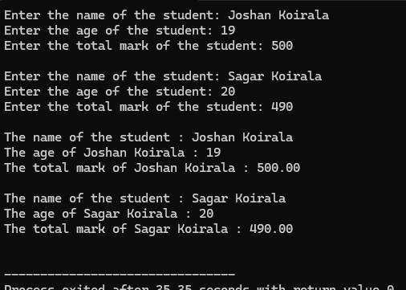

//2) sum of input times.

#include<stdio.h>
struct Time{
int hours;
int minutes;
int seconds;
};
int main() {
struct Time t1, t2, result;
struct Time sum = {0,0,0};
printf("Enter hours for the first time: ");
scanf("%d", &t1.hours);
printf("Enter minutes for the first time: ");
scanf("%d", &t1.minutes);
printf("Enter seconds for the first time: ");
scanf("%d", &t1.seconds);
printf("\n");
printf("Enter hours for the second time: ");
scanf("%d", &t2.hours);
printf("Enter minutes for the second time: ");
scanf("%d", &t2.minutes);
printf("Enter seconds for the second time: ");
scanf("%d", &t2.seconds);
printf("\n");
// operation
sum.seconds = t1.seconds + t2.seconds;
if (sum.seconds >= 60) {
sum.minutes += sum.seconds/60;
sum.seconds = sum.seconds%60;
}
sum.minutes += t1.minutes + t2.minutes;
if (sum.minutes >= 60){
sum.hours += sum.minutes/60;
sum.minutes = sum.minutes%60;
}
sum.hours += t1.hours + t2.hours;
result = sum;
printf ("Sum of the two times:%d hours %d minutes and %d seconds\n",result.hours,result.minutes,result.seconds);
return 0;
}

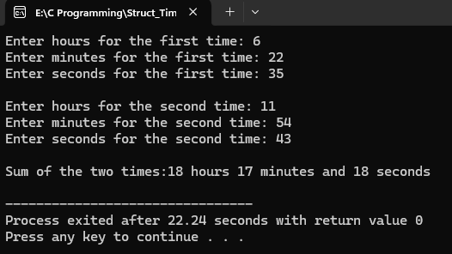

// 3) Book with price between 2000 to 3000 with input of 5 book.
#include<stdio.h>
struct Book{
char title[50];
char author[50];
int price;
}b[5];
int main(){
int i;
for(i=0;i<5;i++){
printf("Enter the title of the book: ");
scanf(" %[^\n]s",b[i].title);
getchar();
printf("Enter the author of the book: ");
scanf(" %[^\n]s",b[i].author);
getchar();
printf("Enter the price of the book: ");
scanf("%d",&b[i].price);
getchar();
printf("\n");
}
printf("Book with price between 2000 and 3000 are:\n");
int found=0;
for(i=0;i<5;i++){
if (b[i].price > 2000 && b[i].price < 3000){
printf("Title: %s, Author: %s, Price: %d\n", b[i].title, b[i].author, b[i].price);
}
found=1;
}

if (!found) {
printf("No books found in this price range.\n");
}
return 0;
}
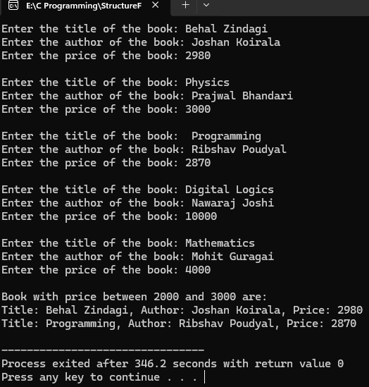

//Program 4 of Structure:
#include<stdio.h>
struct complex{
int real;
int img;
} a[2];
int main(){
int r,i;
printf("enter the value for 1st complex number\n");
printf("enter real part:\n");
scanf("%d",&a[0].real);
printf("enter imaginary part:\n");
scanf("%d",&a[0].img);
printf("1st complex number is: %d + i%d\n",a[0].real,a[0].img);
printf("enter the value for 2nd complex number\n");
printf("enter real part:\n");
scanf("%d",&a[1].real);
printf("enter imaginary part:\n");
scanf("%d",&a[1].img);
printf("2nd complex number is: %d + i%d\n",a[1].real,a[1].img);
r=a[0].real+a[1].real;
i=a[0].img+a[1].img;
printf("the sum of two complex number is: %d + i%d\n",r,i);
return 0;
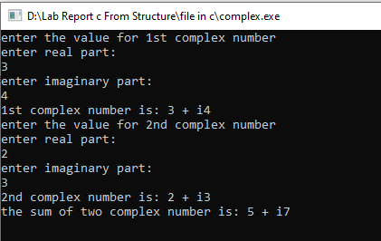
}
Output:

//program 5 of structure;
#include<stdio.h>
#include<string.h>
struct courses{
char c_name[30];
int c_code;
int credit_hours;
} a[3];
int main(){
int i;
for(i=0;i<3;i++){
printf("enter course name:\n");
scanf("%[^\n]s",a[i].c_name);
getchar();
printf("enter course code:\n");
scanf("%d",&a[i].c_code);
getchar();
printf("enter credit hours:\n");
scanf("%d",&a[i].credit_hours);
getchar();
}
for(i=0;i<3;i++){
if(a[i].credit_hours>3){
printf("course name is %s \n course code is: %d\n",a[i].c_name,a[i].c_code);
}
}
return 0;
}
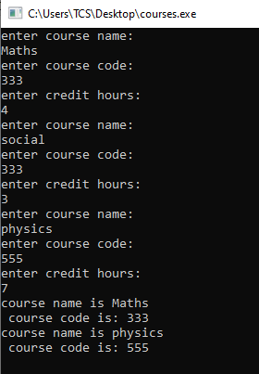
Output:

//first pointer program
#include<stdio.h>
int main(){
int *p,*q,*r;
int a =90,b=50;
p=&a;
q=&b;
int c = *p+*q;
r = p-q;
printf("the value of variable a is :%d\n",*p);
printf("address is : %d\n",p);
printf("sum is %d \n",c);
printf("the diff is :%d\n",r);
if(p>q){
printf("trueee\n");
}
else{
printf("not\n");
}
return 0;
}

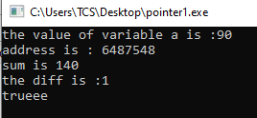
Output:
//second program.
#include<stdio.h>
int main(){
int *p,*q;
int a=30,b=40;
printf("a = %d b = %d\n",a,b);
int temp;
p=&a, q = &b;
temp = *p;
*p=*q;
*q=temp;
printf("swapped value is: \n");
printf("a = %d b = %d",a,b);
return 0;
}

Output:
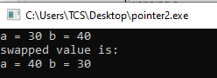
//pointer and array:
#include<stdio.h>
int main(){
int n;
printf("how many elements do you wanna store:\n");
scanf("%d",&n);
int a[n];
printf("enter elements for the array:\n");
int i;
for(i=0;i<n;i++){
scanf("%d",a+i);
}
for(i=0;i<n;i++){
printf("array[%d]=%d\n",i,*(a+i));
}
return 0;

}

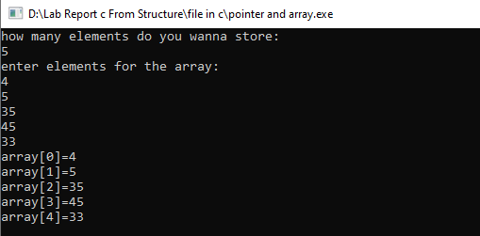
Output:
//Swapping using pass by reference.
#include<stdio.h>
void swap(int *,int *);
int main(){
int a,b;
printf("enter any two numbers: \n");
scanf("%d%d",&a,&b);

swap(&a,&b);
printf("After swapping:\n a=%d,b=%d",a,b);
return 0;
}
void swap(int *a,int *b){
printf("Before swapping:\n a=%d,b=%d",*a,*b);
int temp;
temp=*a;
*a=*b;
*b=temp;
}

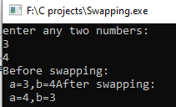
Output:
//pointer to pointer (chain of pointer)
#include<stdio.h>
int main(){
int n;
printf("enter any number\n");
scanf("%d",&n);
int *p;
p=&n;
int **q;
q=&p;
int ***d;
d=&q;
printf("address of pointer 1 is %d\n",p);
printf("address of chain of pointer is :%d\n",q);
printf("address of chain of pointer is :%d\n",d);
printf("value using pointer 1: %d\n",*p);
printf("value using chain of pointer: %d\n",**q);
printf("value using chain of pointer: %d\n",***d);
}

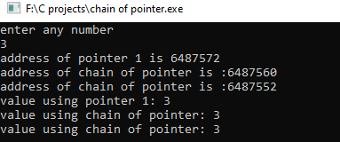
Output:
//without using DMA;
#include <stdio.h>

struct pointer {
int age;
char name[30];
};
int main() {
struct pointer p1;
struct pointer *p;
p = &p1;
printf("Enter your name: ");
scanf(" %[^\n]", p->name);
printf("Enter age: ");
scanf("%d", &p->age);
printf("\nAge is: %d\n", p->age);
printf("Name is: %s\n", p->name);

return 0;
}

Output:
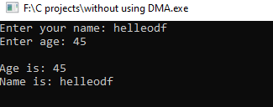
//Demo to DMA and Malloc .
#include <stdio.h>
#include <stdlib.h>

struct pointer {
int age;
char name[30];
} *p;

int main() {
p = (struct pointer *)malloc(sizeof(struct pointer));
if (p == NULL) {
printf("Memory allocation failed!\n");
return 1;
}
printf("Enter your name: ");
scanf(" %[^\n]s", p->name);
printf("Enter age: ");
scanf("%d", &p->age);
printf("\nAge is: %d\n", p->age);
printf("Name is: %s\n", p->name);
free(p);
return 0;
}

Output:
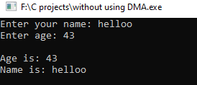
//creating and storing information in a file
#include<stdio.h>
#include<stdlib.h>

int main(){
FILE *f;
f= fopen("file.txt","w");
if(f==NULL){
printf("failed to create \n");
}
else{
printf("successfully created\n");
}
char name[30];
printf("enter your name:\n");
scanf("%[^\n]s",name);
fprintf(f,"%s",name);
return 0;
}
Output:
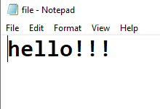
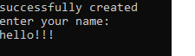
//reading the existing content of file
#include<stdio.h>
#include<stdlib.h>

int main(){
FILE *f;
f= fopen("file.txt","r");
if(f==NULL){
printf("failed to create \n");
}
else{
printf("successfully created\n");
}
char name[30];
fscanf(f,"%s",name);
printf("%s",name);
return 0;
}

Output:

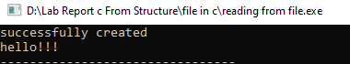
//writing multiple lines in file

#include<stdio.h>
#include<stdlib.h>

int main(){
FILE *f;
f=fopen("file1.txt","w");
if(f==NULL){
printf("file creation unsuccessful\n");
}
else{
printf("file creation successful\n");
}
int n;
printf("how many line do you wanna write:\n");
scanf("%d",&n);
char str[50];
int i;
for(i=1;i<=n;i++){
printf("enter %d line \n",i);
scanf("%s",str);
fprintf(f,"%s\n",str);
}
return 0;
}
Output:

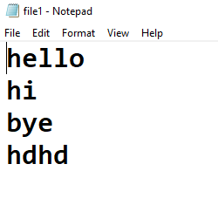
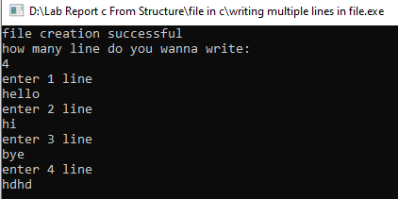

//reading multiple lines from file
#include<stdio.h>
#include<stdlib.h>
int main(){
FILE *f;
f=fopen("file1.txt","r");
if(f==NULL){
printf("file creation unsuccessful\n");
}
else{
printf("file creation successful\n");
}
char name[50];
while(fgets(name,50,f)!=0){
printf("%s\n",name);
}
fclose(f);
FILE *p;
p=fopen("file2.txt","r");
if(p==NULL){
printf("file creation unsuccessful\n");
}
else{
printf("file creation successful\n");
}
int n;
while(fscanf(p,"%d",&n)==1){
printf("%d\n",n);
}
fclose(p);
return 0;
}
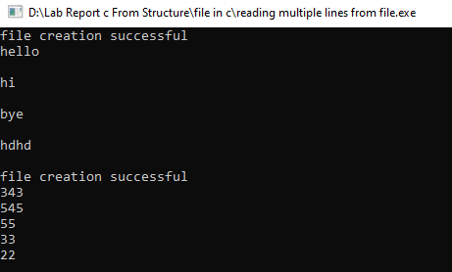
Output:
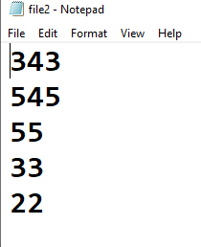


//WAP to input 10 numbers from user and store it on a file named odd.txt and read that file and print only odd number
#include<stdio.h>
#include<stdlib.h>
int main(){
FILE *f;
f = fopen("odd.txt","w");
if(f==NULL){
printf("failed to create file\n");
}
else{
printf("successfully opened file\n");
}
int n[10],i;
printf("enter any 10 numbers\n");
for(i=0;i<10;i++){
scanf("%d",&n[i]);
fprintf(f,"%d\n",n[i]);
}
fclose(f);
FILE *p;
f = fopen("odd.txt","r");
p = fopen("write.txt","w");
if(p==NULL){
printf("failed to create file\n");
}
else{
printf("successfully opened file\n");
}
int a;
while(fscanf(f,"%d",&a)==1){
if(a%2!=0){
printf("odd value : %d\n",a);
fprintf(p,"%d\n",a);
}
}
fclose(f);
return 0;
}

Output:
